|  |  |  |  |  |
| --- | --- | --- | --- | --- |
| **National University of Computer and Emerging Sciences, Lahore Campus** | | | | |
| final design | **Course:** | **Operating System Lab** | **Course Code:** | **CL205** |
| **Program:** | **BS(Computer Science)** | **Semester:** | **Fall 2018** |
| **Duration:** | **45 minutes** | **Total Marks:** | **15** |
| **Quiz Date:** | **29-Nov-2018** | **Weight** | **5** |
| **Section:** | **C** | **Page(s):** | **1** |
| **Exam:** | **Quiz 2** | **Roll No:** |  |

**Question # 1 (15)**

Write a program which implement following architecture. Parent program should print variance on screen.

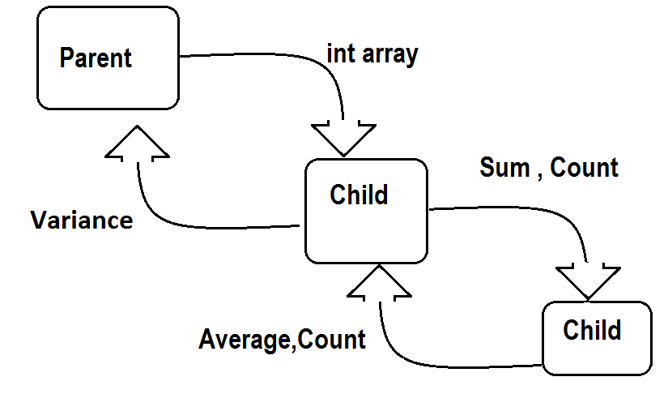

**Variance = ( $\sum_{k=1}^{n}{X_{k}-Average}$) / (n-1)**